Name _________________________________________________________________________________ Period _________________

A Work: Where Will the Continents be in 100 Million Years?
Directions:
- Color each continent its own color. Color both maps exactly the same.
- Carefully cut out the continents on the last page. (just the continent, not the entire plate) of Africa, Eurasia, Indo-Australia, North America and South America.
- Use the speed (inches/yr) in the data table to determine how far each continent will move in 100 million years.
(Speed x 100,000,000) ÷ 12 ÷ 5,280 = _______ miles Enter the distance into the data table.
- Lay the cut-out continents onto the un-cut map. Using the distance traveled data, the movement arrows on the map, and the scale on themap, move the continents to where you think they should be in 100 million years. Glue them to their future location.

Plate | Speed inches/yr | Distance moved in 100M Years
African | 0.3
Eurasian | 0.4
Indo-Australian | 3.3
North American | .9
South American | 1.4

Answer the following questions:
- What will happen to the size of the Pacific Ocean as North America moves west? ________________________________________________

__________________________________________________________________________________________________________________

- What will happen to the location of North America and South America as sea-floor spreading widens the Atlantic Ocean? _______________

__________________________________________________________________________________________________________________

- What might happen to the Himalayas over the next million years? Give a reason for your answer. ___________________________________

__________________________________________________________________________________________________________________

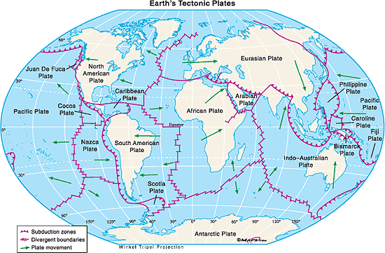

0 1,000 2,000 Miles

